Club History
The Club began in 1997 when a group of anglers got together to stock Atlantic salmon in the East Branch of Fish Creek. After the initial stocking club members worked with Margaret Murphy, a SUNY ESF doctoral student, to complete her field work. After completion of her field work in 2000, a hatchery in Lew Beach was found willing to hatch and raise salmon fry for the club. In 2005 the club decided to build a hatchery in Annsville to hatch salmon eggs ourselves. The hatchery was moved to McConnellsville during the fall of 2010.

Over the past 18 years we’ve learned to deal with snow, cold temperatures, ice, hot temperatures, floods, low water, water quality issues, transportation of eggs and fry, predation as well as the technical challenges of fish culture to successfully incubate and stock fish each year. In support of its restoration goal the Club has stocked over 500,000 fish including almost 60,000 fry donated by the Ed Weed Fish Cultural Station in Grand Isle, Vermont.
Developments for 2016
The club had an up and down year in 2016
First, Justin DiRado and Chris Powers, two of Professor Neil Ringler’s graduate students from ESF, completed a comparative study to evaluate growth, survival and movement of two strains of Atlantic salmon in Lake Ontario and Oneida Lake tributaries. The two year study by Justin and Chris included field work along with laboratory work and on January 28, 2016, a presentation of the results was made to the club.
The results of the study are as follows:
- Memphremagog strain did better in Lake Ontario tributaries where water temperatures were higher.
- Memphremagog strain is not readily available
- Memphremagog and Sebago growth rates about the same in Fish Creek Tributaries
- The fish did well in Point Rock creek but because of Kessinger Dam is not ideal.
- Furnace Creek is ideal because it is reachable to spawning salmon and the fish did well there.
- Oswego river system is the largest river system where Atlantic salmon have been known to spawn.
- Fish Creek tributaries in Lewis county would be good areas for Atlantics if adults made the reservoir their home.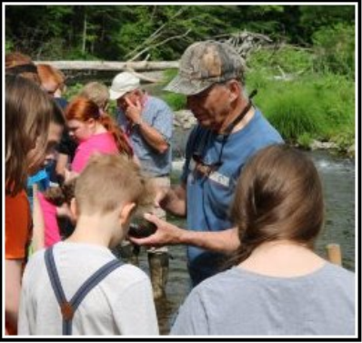
Camden Middle school students on the Mad river learning about river ecology
Second, the club received salmon eggs on Jan 4 and then later we got word that all of the eggs we had given to the Camden Middle school had died over a weekend. During February a pipe froze and we lost 3500 salmon. Then the pipe supplying water to the incubator got plugged up and we lost all of the remaining fish.
Third, the club started a search to find out if other fish hatcheries had excess fish they could donate to the club. Eisenhower National Fish Hatchery in Chittenden Vermont indicated that they had 4 to 5,000 fry and 15 to 18,000 fish at the sac fry stage. On May 28 we stocked the Atlantic salmon from Vermont after transporting them to our hatchery.
Fourth, the club saved some of the salmon from Vermont and on June 6 club members helped students from the Camden Middle School stock Brook trout and Atlantic salmon in the Mad river in our on-going effort to support Trout in the Classroom.
Fifth, on June 10 the club stocked 10,000 Atlantic salmon we got from the Adirondack Fish Hatchery after club member traveled over night to transport the fish to Taberg.
The club has been fortunate that so many people have helped in one way or another. Re-storing Atlantic salmon to waters they once used to live in has truly become a community event and club members are grateful for the continuing support.

