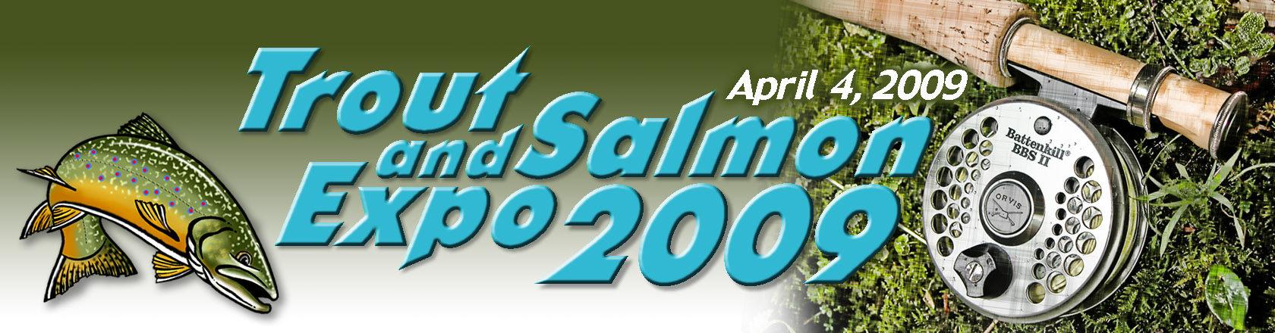

TROUT AND SALMON EXPO 2009
APRIL 4, 2009 10AM-4PM
NEW HARTFORD COMMUNITY CENTER

Building on the success of last year, this years EXPO is expected to draw even more visitors from all regions of upstate New York. The TU Trout and Salmon Fishing Expo will feature a diverse lineup of fishing tackle and equipment, and seminars designed to increase your knowledge of area streams. It will include fly and bait casting demonstrations, rod building, fly tying, casting contest, as well as a trout in the classroom exhibit. The highlight of the program will be in depth discussions of “how to” fish our most popular fisheries; The West Canada, the Delaware, Fish Creek, Salmon River, the Oriskany, and Lake Ontario.
Bob Janiga -West Canada Techniques
Rick Pecci Lake Ontario,
Paul Miller –Atlantic Salmon,
Billy Girvan-Bait fishing
David Corr - Adirondack Brook Trout Fishing
Entomology-Joe Alberico
Bill Ingersoll (author)-contacted to speak
Bob Lewis, casting demonstration and clinic

Exhibitors booked to date include the DEC Fish Tank Exhibit, Holland Patent School Trout in the Classroom exhibit, Strike Zone outfitters for Lake Ontario, Russ Hart wood carver extraordinaire Utica Zoo mobile, NYS Hall of Fame, John Patterson (Flies), Gander Mountain exhibit and casting contest, Casting for Recovery, West Canada River Keepers, Bob Lewis, Adirondack Angler, Morrisville College table and tank display, crafts/activity booth, ENCON Police, and Tom Lenweaver, Wild Life Artist

FOR INFORMATION ON THE EXPO PLEASE CONTACT

Ken Ziobro at kziobro@verizon.net, Dave Corr at dkcorr@netscape.com
or
http://www.tumohawkvalley.org/expo2009.htm

